SCOTLAND CUP - 30th Papa Joe McGill Land O’ Burns Tournament & Festival AYR – SCOTLAND 5th & 6th AUGUST 2023
FANTASTIC PRE-SEASON TOURNAMENT – PERFECT PREPARATION FOR THE NEW SEASON - TOURNAMENT INFORMATION
AGE CLASSIFICATIONS: ALL Players Born on or after 1st January in the respective year International Team Dispensation will be granted to all teams from countries that do not have the 1st of January as the qualification date. ALL teams entering this tournament by applying and being accepted to participate agree to the granting of this dispensation to teams from out-with Scotland. (Maximum of 5 players per team)
5th & 6th AUGUST 2023 | 4th , 5th & 6th AUGUST 2023
BOYS 11 A-SIDE | BOYS 9 A-SIDE | Super Fives and Fun Fours
Age 13 – 2011’s - £195 per team | Age 11 – 2012’s - £115 per team | Super Fives
Age 14 – 2010’s - £195 per team |  | Age 8 – 2015’s - £45 per team
Age 15 – 2009’s - £195 per team
Age 16 – 2008’s - £195 per team | BOYS 7 A-SIDE | Fun Fours
 | Age 10 – 2013’s - £95 per team | Age 7 – 2016’s - £45 per team
 | Age 9 – 2014’s - £95 per team | Age 6 – 2017’s - £45 per team
NOTE
When completing your application form for the 7 & 9 a-side Festival please indicate the strength of your team. Advanced being the strongest and Development the weakest. This will enable us to cast equal fixtures giving your players the best experience. THIS DOES NOT APPLY TO SUPER 5’s OR FUN 4’s

TOURNAMENT PROGRAMME: (11 A-Side) Subject to confirmation  FRIDAY 4th AUGUST 2023  TEAM ARRIVALS (Residential Teams)  SATURDAY 5th AUGUST 2023 11 A-Side Group Matches ALL Day  SUNDAY 6th AUGUST 2023 11 A-Side Final Group Matches / Semi Finals / Finals | FESTIVAL PROGRAMME: (Fun 4’s, Super 5’s, 9 and 7 A-Side) Subject to confirmation FRIDAY 4th AUGUST 2023  Fun 4’s & Super 5’s Festival  SATURDAY 5th AUGUST 2023 9 A-Side and 7 A-Side Festival Matches, SUNDAY 6th AUGUST 2023 9 A-Side and 7 A-Side Festival Matches

NUMBER OF MATCHES: 11 A-Side: ALL teams guaranteed a minimum of 4 or a maximum of 5 matches. ALL matches two 25 minute halves 9 A-Side: ALL teams guaranteed to play 6 matches (3 each day) ALL matches one 25 minute period 7 A-Side: ALL teams guaranteed to play 6 matches (3 each day) ALL matches one 25 minute period SUPER 5’s: ALL teams guaranteed to play 5 matches. ALL matches one period of 10 minutes FUN 4’s: ALL teams guaranteed to play 5 matches. ALL matches one period of 10 minutes
ACCOMMODATION – TEAMS SHOULD CONTACT THE SCOTLAND CUP OFFICE

Scotland Cup Tournaments, PO Box 8509. Largs KA30 0AZ Scotland. Tel: +44 (0)7581 223781 * Email: info@scotlandcup.com * Web: www.scotlandcup.com

30th Papa Joe McGill Land O’ Burns Tournament & Festival SCOTLAND CUP - TEAM APPLICATION FORM
ALL SECTIONS MARKED * MUST BE COMPLETED IN FULL ANY FORMS NOT COMPLETED CORRECTLY WITH ALL THE REQUIRED INFO WILL BE RETURNED
Team Name: | National Association: |  | Registration Number: (SYFA)
* Name of League you play in: | * Current League Position: |  | * League Position Last Season:
* Team Colours: * Tops:  * Shorts:  * Socks: |  | * Team Colours (Alternative): * Tops:  * Shorts:  * Socks:
Contact Name and position with team: |  | * Telephone Number (Daytime / Evening):
* Address: |  | * Mobile Number:
- Country: |  | * Email Address:
ALL confirmations and correspondence with participating team’s will be done by EMAIL Mark the Age(s) you wish to enter with a X. Ages as-on 1st January in respective year.
5th & 6th AUGUST 2023  11 A-SIDE |  |  |  | 4th AUGUST 2023 – Fun 4’s and Super 5’s  5th & 6th August 2023 9 a-side and 7 a-side
11 a-side | Age 2011  13’s | £195 |  | 9 a-side  2012 | £115 |  | Advanced | Intermediate | Development
11 a-side | Age 2010  14’s | £195 |  | 7 a-side  2013 | £95 |  | Advanced | Intermediate | Development
11 a-side | Age 2009  15’s | £195 |  | 7 a-side  2014 | £95 |  | Advanced | Intermediate | Development
11 a-side | Age 2008  16’s | £195 |  | Super 5’s 2015 | Age 8  £45 |  | For the Small Sided Festival at 7 & 9 a-side please indicate the strength of your team. Advanced being the strongest and Development the weakest. This will enable us to cast equal fixtures giving your players the best experience. This does NOT apply to the SUPER 5’s or FUN 4’s
 |  |  |  | Fun 4’s  2016 | Age 7  £45
 |  |  |  | Fun 4’s  2017 | Age 6  £45

PAYMENT | Number of Teams: | Total Payment  £
Accommodation: Teams book their own accommodation; you can also contact the Scotland Cup Office for assistance.
On behalf of the above-named team(s), I / We hereby make application for entry to the Scotland Cup Tournament and confirm ALL information provided is CORRECT and if successful agree to abide by the Tournament Rules
Signed………………………………………,………………………: Print Name:……………………………………………………………….
Position in Team: …………………………………………………… Date:………………………………………………………………………
PAYMENTS: By Cheque payable to:- SCOTLAND CUP TOURNAMENTS OR Directly to the Tournament Bank Account: Bank of Scotland, 123 High Street, Ayr Sort Code: 80 22 60 * Account Number: 22187966 * Account Name: Scotland Cup Tournaments BIC: BOFSGBS1SDP * IBAN: GB15 BOFS 8022 6022 1879 66 TEAMS ARE RESPONSIBLE FOR ALL BANK CHARGES
PLEASE REMEMBER TO INCLUDE THE NAME OF YOUR TEAM WHEN PAYING DIRECTLY TO THE BANK
Please download and complete this application form and email to info@scotlandcup.com You can also post the form complete with entry fee to: Scotland Cup Tournaments, PO Box 8509, Largs. KA30 0AZ Scotland. Tel: +44 (0)7581 223781 www.scotlandcup.com
2023 SCOTLAND CUP - ACCOMMODATION INFORMATION

University of the West of Scotland - AYR
10/15-minute drive to Tournament Venue and 5/10-minute walk to Ayr Town Centre & the Beach
The accommodation is in modern flats comprising of FIVE ensuite single bedrooms per flat.
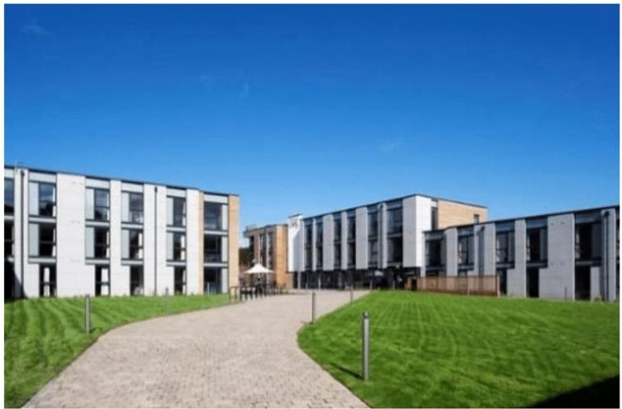
Each flat has its own kitchen/lounge with cooking facilities if required. Bedding, towels, and kitchen/cooking equipment (if required) are supplied.
UWS Costs:
Self-Catering
£43 per room per night

A Continental Breakfast pack is available.
Cost - £5.50 per person per day.

Teams can also bring their own provisions.
ALL crockery, cooking utensils etc. are supplied.

To book this accommodation contact the Scotland Cup Office
07581 223781
info@scotlandcup.com

Adamton Country House Hotel (Three Star) By Ayr
Set in its own 20 acres of ground on the outskirts of Ayr, a 20/25-minute drive.
Adamton Hotel

Based on 2 sharing
Twin or Double Room
Costs per room
Bed & Breakfast
1 night £75
2 nights £150
3 nights £225

A small number of family are available please ask for details.

To book this accommodation contact the
Scotland Cup Office
07581 223781
info@scotlandcup.com

to the tournament venue and Ayr Town Centre.
Double- & Twin-Bedded rooms all ensuite. Outside grass areas for a kick
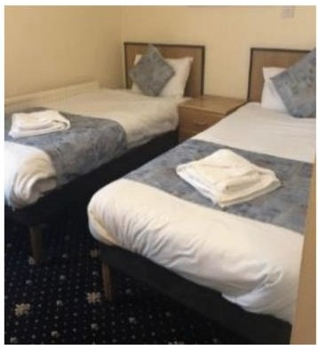
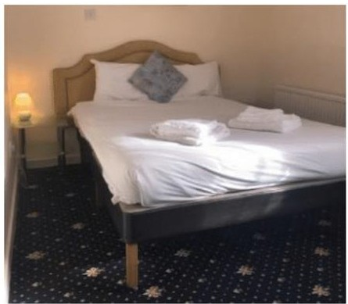
about or training session and floodlit 5 a-side courts.

ALL ACCOMMODATION IS SUBJECT TO AVAILABILITY AT TIME OF BOOKING
PLEASE CONTACT THE SCOTLAND CUP OFFICE 07581 223781 * info@scotlandcup.com

